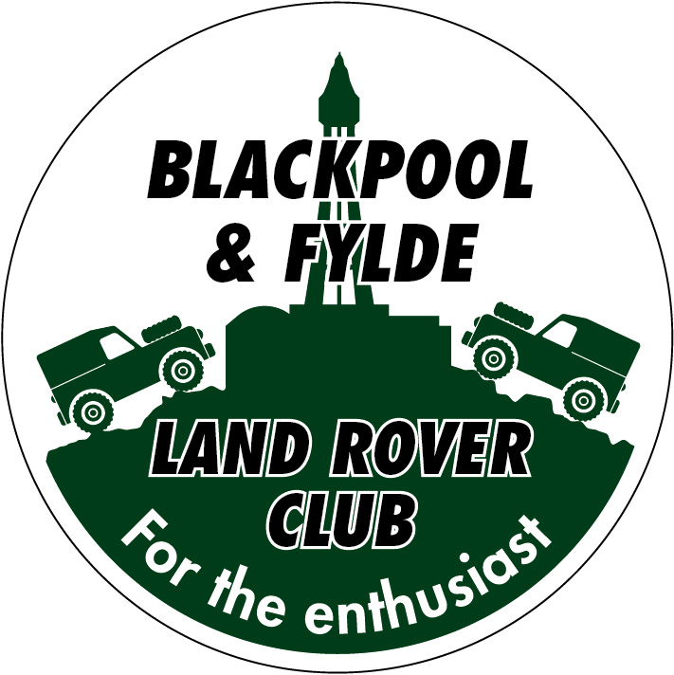
Club Clothing

Classic polo - Sizes: XS to 2XL £12.00 Sizes: 3XL to 4XL £13.00 (No 5XL or 6XL)
Colours: Black, French Navy, Hot Pink, Bottle Green, Heather Grey, Maroon, Charcoal, Kelly Green, Navy, Orange, Purple, Red, Royal Blue, Sapphire Blue, Sky Blue, White, Yellow
Classic Hooded Sweatshirt - Sizes: XS to 2XL £20.00 Sizes: 3XL to 6XL £21.00
Colours: Black, Bottle Green, Brown, Charcoal, Heather Grey, Hot Pink, Jade, Kelly Green, Maroon, Navy, Military Green, Olive, Orange, Pink, Purple, Red, Royal Blue, Sapphire Blue, Sky Blue, Violet, White, Yellow
Classic full zipped micro Fleece Jacket with side pockets - Sizes: XS to 2XL £20.00 Sizes: 3XL to 4XL £21.00
Colours: Black, Bottle Green, Charcoal, Maroon, Navy, Red, Royal Blue (No 5XL or 6XL)
Ladies Classic full zipped Fleece Jacket with side pockets - Sizes: XS to 4XL £20.00 (No 5XL or 6XL)
Colours: Black, Navy, Red, Royal Blue
Classic T shirt - Sizes: XS to 2XL £10.00 Sizes: 3XL to 6XL £11.00
Colours: Black, French Navy, Hot Pink, Bottle Green, Heather Grey, Maroon, Charcoal, Kelly Green, Navy, Orange, Purple, Red, Royal Blue, Sapphire Blue, Sky Blue, White, Yellow

SIZE GUIDE
Size | To fit chest | Size | To fit chest
XS | 36” – 38” | S | 38” – 40”
M | 40” – 42” | L | 42” – 44”
XL | 44” – 46” | 2XL | 46”- 48”
3XL | 50” – 52” | 4XL | 52” – 54”
5XL | 54” – 56” | 6XL | 58” – 60”

Please note that the Ladies Fleeces are smaller – we would recommend that you order a size larger than you would usually buy
SPECIAL OFFER - Buy a hoodie or fleece and a polo shirt XS to 2XL £30.00 3XL to 4XL £32.00
PTO
CLOTHING ORDER FORM
NAME
ADDRESS

TELEPHONE NUMBER

Item | Colour | Size | Quantity | Price
 |  |  | Total

Payment to be made when placing the order
Cash or Direct transfer:
Sort code: 20-45-45 Account: 20611794
Thank you

